# Buffon’s Needle Problem

French nobleman Georges Louis Leclerc, Comte de Buffon was one of the first scholars to explore the area of mathematics known as geometric probability. In 1733 during a lecture at the Royal Academy of Sciences in Paris, he posed his famous needle problem which asked:

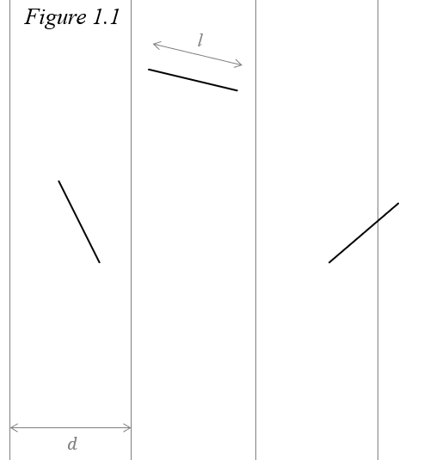Suppose that you drop a needle of length $l$ on ruled paper with lines at a constant interval $d$—what is then the probability that the needle comes to lie in a position where it crosses one of the lines?[1]

First, let us establish a few definitions for clarity.

*Position -* the needle is assumed to be a one-dimensional line segment. Its position is the midpoint this line. Denoted $M$.

*Separation distance -* the shortest distance between the closest parallel line and the position of the needle. It is equal to the length of the shortest line connecting $M$ and the nearest parallel line. Denoted $x$.

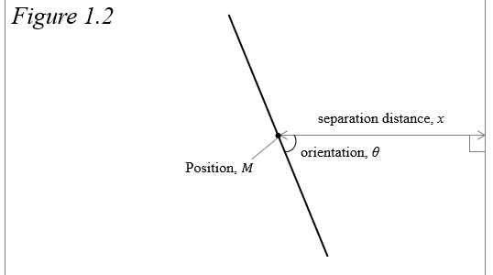*Orientation -* refers to the smaller of the two angles formed between the needle and the line segment representing separation distance. Denoted $θ$ and $0≤θ≤\frac{π}{2}$.

There are two factors to consider when trying to solve Buffon’s needle problem: where the needle lands in relation to the lines, and how it is oriented. We are assuming that the needle is dropped completely randomly, so $M$ is equally likely to be at every point on the plane, and every value of $θ$ is equally likely to occur. With these assumptions, let us find the probability density functions (pdf) of $x$ and $θ$.

Imagine the plane on which the needle is falling is a coordinate plane and the parallel lines are vertical. In this situation, changes in $x$ alter the range of values of $θ$ that will result in a success; as $x$ decreases, this range grows, and as $x$ increases, this range shrinks. Since the lines are perfectly straight and extend infinitely, a change in the y-coordinate does not change $x$, so the y-coordinate does not affect the probability of a success and can therefore be ignored. Because $M$ is equally likely to fall anywhere, each value of $x$ is equally likely, meaning that the pdf of $x$, $f\left(x\right)$, is uniform. The needle is farthest from either line when $M$ is in the middle of two lines, and closest when it is directly on a line, so $x$ is in the interval $\left[0,d/2\right]$.

$$\begin{aligned}f\left(x\right)=\frac{2}{d}, 0≤x≤\frac{d}{2} \#\left(1.1\right)\end{aligned}$$

The range of the values of $θ$ is restricted to the interval $\left[0, π/2\right]$ because it represents all the unique possiblities of how the needle is oriented. As mentioned earlier, each value in this interval is equally likely to occur so the pdf of $θ$, $f\left(θ\right)$, is also uniform:

$$\begin{aligned}f\left(θ\right)=\frac{2}{π} , 0≤θ≤\frac{π}{2} \#\left(1.2\right)\end{aligned}$$

Also, the orientation of the needle has no effect on its position and vice versa, so these variables can be considered independent.

Finally, we must discern between a long needle where $l>d$ and a short needle where $l<d$ because it is possible for a long needle to land on a line at any $x$, but this is not the case for a short needle. As such, the two possibilities lead to different solutions. Call $C_{S}$ the event that a short needle crosses the line and $C_{L}$ the event a long needle crosses the line.

## Short Needle

A short needle needs to land both close enough to the line and have the correct orientation for $C_{S}$ to occur. Call these events $D_{S}$ and $O_{S}$ respectively. Since these events are based on $x$ and $θ$, and the variables are independent, the events are also independent. This means that we can solve for the probability of a short needle success by multiplying the probability the needle lands close enough to a line and the probability it is correctly oriented.

$$\begin{aligned}P\left(C_{S}\right)=P\left(D_{S}∩O_{S}\right)=P\left(D_{S}\right)∙P\left(O_{S}\right)\#\left(1.3\right)\end{aligned}$$

### Separation Distance

The range of values of $x$ is $0≤x≤d/2$. A success occurs at an $x$ value small enough so that the needle is close enough to cross a line. Since the needle’s position is measured at its midpoint, a success occurs when $x<l/2$. To find the probability $D_{S}$ is a success, we can simply divide the range of values of $x$ which yield a success by the total range of values.

$$\begin{aligned}P\left(D_{S}\right)=\frac{\frac{l}{2}-0}{\frac{d}{2}-0}=\frac{l}{2}∙\frac{2}{d}=\frac{l}{d} \#\left(1.4\right)\end{aligned}$$

### Orientation

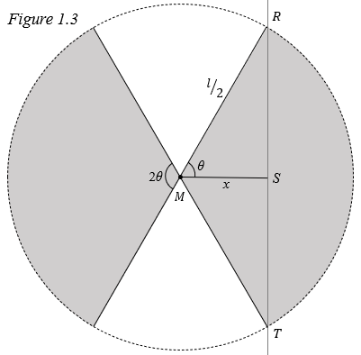To find the probability $O_{S}$ is a success, let us first look at the probability that at a fixed $x$, the needle will cross the line, assuming $x<l/2$. Because $x$ is kept constant, we can imagine the needle is fixed at its midpoint but is free to rotate about this point. When rotated, the needle traces out a circle with center $M$ and radius $l/2$ which represents every possible position the needle can be oriented. The circle intersects the line at two points; call these $R$ and $T$. Drawing lines from these points through $M$ forms two sectors in which the needle must fall for a success, represented by the shaded regions in *figure 1.3*. The “head” of the needle can lie in either sector because if it does not cross the line, its “tail” will. We can divide the area of the two sectors by the total area of the circle to find the probability the needle falls in either sector.

$$\begin{aligned}P=\frac{2∙ \frac{1}{2}r^{2}2θ}{πr^{2}}=\frac{2θ}{π}, 0≤θ≤\frac{π}{2}\#\left(1.5\right)\end{aligned}$$

The shortest distance from a line to a point is formed a line by a perpendicular to the original line so ∠RSM is a right angle. Therefore, the inverse cosine can be used to find *θ*:

$${θ=cos}^{-1}\left(\frac{ x }{\frac{l}{2}}\right)$$

$$\begin{aligned}θ=\cos^{-1}\left(\frac{2x}{l}\right) \#(1.6)\end{aligned}$$

Substituting into $(1.5)$:

$$\begin{aligned}P=\frac{2\cos^{-1}\left(\frac{2x}{l}\right) }{π}, 0≤x≤\frac{l}{2} \#\left(1.7\right)\end{aligned}$$ This equation gives the probability that a short needle of length $l$ crosses $\overline{RT}$ at some value of $x$. If $x>l/2$, then the probability that the needle crosses is 0. Now, to find $P\left(O_{S}\right)$, we must find the *typical* probability that a needle dropped randomly between 0 and $l/2$ units from a line is oriented so that it crosses. To do this, we can take the average probability of $(1.7)$.

$$\begin{aligned}P\left(O_{S}\right)=\frac{1}{l/2-0}\int_{0}^{\frac{l}{2}}{ \frac{2\cos^{-1}\left(\frac{2x}{l}\right) }{π}}dx \end{aligned}$$

Substituting $u={2x}/l$ and $du=2/ldx$:

$$\begin{aligned}= \frac{4}{lπ}\int_{0}^{1}{ \frac{l\cos^{-1}\left(u\right)}{2}}du \end{aligned}$$

$$=\frac{2}{π}\int_{0}^{1}{\cos^{-1}\left(u\right)}du$$

Integrating by parts:

$$=\frac{2}{π} \left(u\cos^{-1}{u}-\int_{0}^{1}{-\frac{u}{\sqrt{1-u^{2}}}}du\right)$$

Looking just at the integral, substitute $v=1-u^{2}$ and $dv=-2udu$. We will not change the bounds to be in terms of $v$ because $u$ will eventually be substituted back in.

$$\int_{0}^{1}{-\frac{u}{\sqrt{1-u^{2}}}}du=\int_{0}^{1}{-\frac{u}{-2u\sqrt{v}}}dv$$

$$=\frac{1}{2}\int_{0}^{1}{\frac{1}{\sqrt{v}}}dv$$

$$=\frac{1}{2} {\left.\left(2\sqrt{v}\right)\right|}_{0}^{1}$$

Substituting *u*:

$$\frac{1}{2} {\left.\left(2\sqrt{v}\right)\right|}_{0}^{1}={\left.\left(\sqrt{1-u^{2}}\right)\right|}_{0}^{1}$$

Replacing the integral with ${\left.\left(\sqrt{1-u^{2}}\right)\right|}_{0}^{1}$:

$$\frac{2}{π} \left(u\cos^{-1}{u}-\int_{0}^{1}{-\frac{u}{\sqrt{1-u^{2}}}}du \right)= \frac{2}{π} {\left.\left(u\cos^{-1}{u-\sqrt{1-u^{2}}}\right)\right|}_{0}^{1}$$

$$= \frac{2}{π} \left[\left(1\cos^{-1}\left(1\right)-\sqrt{1-1^{2}}\right)-\left(0\cos^{-1}\left(0\right)-\sqrt{1-0^{2}}\right)\right]$$

$$\begin{aligned}P\left(O_{S}\right)=\frac{2}{π} \#\left(1.8\right)\end{aligned}$$

Now we can multiply our two probabilities to find the probability of $C_{S}$.

$$\begin{aligned}P\left(C_{S}\right)=P\left(D_{S}\right)∙P\left(O_{S}\right)\end{aligned}$$

$$\begin{aligned}P\left(C_{S}\right)=\frac{2l}{πd} \#\left(1.9\right)\end{aligned}$$

## Long Needle

When $l>d$, the needle will be able to cross a line at any value of $x$, so we only need to address $θ$. Like the method for the short needle, we can find the average of $(1.7)$ to find the probability of $C_{L}$. The only difference is that we instead find the average on the interval $\left[0,d/2\right]$ because again, the needle is long enough to cross a line at every value of $x$.

$$\begin{aligned}P\left(C_{L}\right)=\frac{1}{d/2-0}\int_{0}^{\frac{d}{2}}{ \frac{2\cos^{-1}\left(\frac{2x}{l}\right) }{π}}dx\end{aligned}$$

$$=\frac{2}{d}∙\frac{2}{π}\int_{0}^{\frac{d}{2}}{ \cos^{-1}\left(\frac{2x}{l}\right)}dx$$

The calculations are similar to those of the short needle and we end with:

$$\frac{2l}{πd}{\left.\left(u\cos^{-1}{u-\sqrt{1-u^{2}}}\right)\right|}_{0}^{\frac{d}{l}}$$

$$\begin{aligned}P\left(C_{L}\right)=\frac{2l}{πd}\left(\frac{d}{l}\cos^{-1}\left(\frac{d}{l}\right)-\sqrt{1-{\left(\frac{d}{l}\right)}^{2}}+1\right) \#\left(1.10\right)\end{aligned}$$

## Solution

Call $C$ the event where a needle of length $l$ will cross a line, given a floor with equally spaced parallel lines a distance $d$ apart. The probability of $C$ is a combination of the probabilities of $C_{S}$ and $C_{L}$:

$$\begin{aligned}P(C)=\left\{\begin{aligned} \frac{2l}{πd} for l≤d \\ \frac{2l}{πd}\left(\frac{d}{l}\cos^{-1}\left(\frac{d}{l}\right)-\sqrt{1-{\left(\frac{d}{l}\right)}^{2}}+1\right) for l>d\end{aligned}\right. \#\left(1.11\right)\end{aligned}$$

Notice that when $l=d$, the expression in the parenthesis simplifies to $1$ and the solution for a long needle becomes the same as the solution for a short needle, so either solution works in this case.

Interestingly, $π$ appears in the solution. Looking just at the solution to the short needle, we can rearrange it:

$$π=\frac{2l}{Pd}$$

This equation can be used to approximate the constant using Monte Carlo methods. In 1850, Johann Rudolf Wolf performed Buffon’s needle problem with 5000 needles which were 36mm long and parallel lines 44mm apart.[2] His experiment yielded the experimental probability 0.5064 which can be substituted into the equation above and results in an approximation of $π$ which is only about 0.57% from the true value.

# Works Cited

Aigner, Martin, and Günter M Ziegler. *Proofs from THE BOOK*. Springer-Verlag, 2004.

D-Orrie, Heinrich, et al. *100 Great Problems of Elementary Mathematics: Their History and Solution*. United Kingdom, Dover Publications, 1965.

1. Aigner, Martin, and Günter M Ziegler. Proofs from THE BOOK. Springer-Verlag, 2004.
2. D-Orrie, Heinrich, et al. *100 Great Problems of Elementary Mathematics: Their History and Solution*. United Kingdom, Dover Publications, 1965, p.77